Innovation + Learning Center Simulation Scenario Planning Worksheet
Scenario
Estimated Scenario Time
Estimated Debriefing Time
Name and Contact Information
Facilitator
Target Group/Department
Size of Group
Run Through and Proposed Start Date
Studio Preference | □ Main Studio □ 239 Studio □ Mount Sinai Studio
Any Supporting Images for Studio Monitors? (ex. Labs, x-rays, ECG’s)
Simulated Setting
(Where this scenario would be taking place)
Will you be requiring a Manikin □ or a Standardized Patient □?
Patient Description
Name and Gender
Age
Weight
Height
Medications
Allergies
Beginning State of Manikin:
Lung Sounds
Heart Sounds
Bowl Sounds
Pulses
Initial Vitals:
Heart Rate
Heart Rhythm
Respiration Rate
Sp02
Blood Pressure

Please Describe what Triggers the Vital Changes and Specify Manikin Dialogue
Vital Changes/Trends
Heart Rate
Heart Rhythm
Respiration Rate
Sp02
Blood Pressure
Lung Sounds
Heart Sounds
Bowl Sounds

Patient History Pre- Hospital

Equipment Checklist
Equipment that should be readily available for the scenario
PPE (goggles, gloves, etc)
Reference Material
Monitor/Defib/AED
Lab Reports
Medical Records
Oxygen Delivery
Crash Cart
Medication & IV Fluids
Bedside Table
IV Pole
Studio Code Recording for Debriefing Purposes
Anything Specific Camera Angle should Capture?
Debriefing Location Preference? | Simulation Studio (Capacity: 12 Participants)
 | Idea Lab (Capacity: 10-20 Participants)
 | Center Stage (Capacity: 16-25 Participants)
 | Collaborative Theatre (Capacity: 32-100 Participants)
 | Room 239 (Capacity: 12 Participants)
 | Room 216 (Capacity: 35-50 Participants)
 | Room 217 (Capacity: 12-24 Participants)

Learning Objectives for Tagging Purposes
Example from Nurse Resident Rapid Response Simulation:
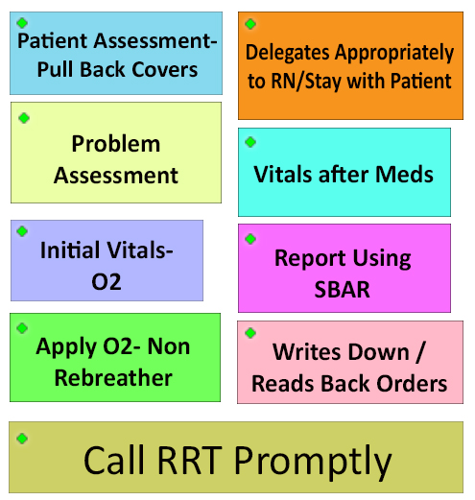

Initial Interventions

Response to Interventions, Secondary Assessment, Scenario Progression Details

Any other Comments or Details Needed for Simulation?

